上海健康医学院

《健康数据挖掘》
实验报告

院（系）: 医疗器械学院
课 程: 健康数据挖掘
专业班级：22级数据科学与大数据技术2班
学生姓名： 周雨晴 黄孝清
指导教师： 任和

综合实验

总流程：数据增强+贝叶斯优化调参+机器学习+交叉10折验证
运行代码：
- import os
- import json
- import pickle

- import antropy
- import numpy as np
- import pandas as pd
- import scipy.io as sio
- from scipy.signal import welch
- from scipy.stats import skew, kurtosis
- import pywt
- import antropy as ant

- # XGBoost模型
- import xgboost as xgb

- # 处理&评估
- from sklearn.model_selection import StratifiedGroupKFold, train_test_split, learning_curve
- from sklearn.preprocessing import StandardScaler, LabelEncoder
- from sklearn.metrics import accuracy_score, f1_score, confusion_matrix, classification_report, precision_score, recall_score
- from sklearn.pipeline import Pipeline
- import time

- # 贝叶斯优化相关库
- from skopt import BayesSearchCV
- from skopt.space import Real, Categorical, Integer

- import warnings

- # ==========================================
- # 0. 全局配置（删除所有可视化相关配置）
- # ==========================================
- warnings.filterwarnings('ignore')

- FS = 200
- N_SAMPLES = 1024
- CLASSES = ['interictal', 'preictal', 'ictal']
- DATASET_PATH = r".\EEGEpilepsyDatasets" # 数据集路径

- # 结果保存根目录（删除PLOTS_DIR，无需保存图片）
- RESULTS_ROOT = r".\A10_eeg_epilepsy_lasso0.5_plus1"
- os.makedirs(RESULTS_ROOT, exist_ok=True)

- # 子目录（仅保留必要目录，删除绘图相关的PLOTS_DIR、DATA_FOR_PLOTS_DIR）
- FEATURES_DIR = os.path.join(RESULTS_ROOT, "features")
- MODELS_DIR = os.path.join(RESULTS_ROOT, "models")
- REPORTS_DIR = os.path.join(RESULTS_ROOT, "reports")

- for dir_path in [FEATURES_DIR, MODELS_DIR, REPORTS_DIR]:
- os.makedirs(dir_path, exist_ok=True)

- # ==========================================
- # 1. 数据加载
- # ==========================================
- def load_raw_data(root_path):
- raw_signals = []
- labels = []
- print(f"--- [Step 1] Loading Raw Data from {root_path} ---")
- if not os.path.exists(root_path): raise FileNotFoundError(f"错误：路径 {root_path} 不存在！")
- for class_name in CLASSES:
- folder_path = os.path.join(root_path, class_name)
- if not os.path.exists(folder_path):
- print(f"警告: 文件夹 {class_name} 不存在，跳过。")
- continue
- files = [f for f in os.listdir(folder_path) if f.endswith('.mat')]
- print(f" -> Loading {class_name}: {len(files)} files")
- for file in files:
- try:
- mat_data = sio.loadmat(os.path.join(folder_path, file))
- key = [k for k in mat_data.keys() if not k.startswith('__')][0]
- signal = mat_data[key].flatten()
- if len(signal) >= N_SAMPLES:
- raw_signals.append(signal[:N_SAMPLES])
- else:
- raw_signals.append(np.pad(signal, (0, N_SAMPLES - len(signal)), 'edge'))
- labels.append(class_name)
- except Exception as e:
- print(f"Error loading {file}: {e}")
- if len(raw_signals) == 0: raise ValueError("未加载到任何数据，请检查数据集路径。")
- return np.array(raw_signals), np.array(labels)

- # ==========================================
- # 2. 特征提取
- # ==========================================
- class EEGFeatureExtractor:
- def __init__(self, fs=200, window_len=2, overlap=0.5):
- self.fs = fs
- self.window_samples = int(window_len * fs)
- self.step_samples = int(self.window_samples * (1 - overlap))
- self.bands = {'Delta': (0.5, 4), 'Theta': (4, 8), 'Alpha': (8, 13),
- 'Beta': (13, 30), 'Gamma': (30, 70)}

- def _get_windows(self, sig):
- windows = []
- n_samples = len(sig)
- if n_samples < self.window_samples:
- return [sig]
- for start in range(0, n_samples - self.window_samples + 1, self.step_samples):
- windows.append(sig[start: start + self.window_samples])
- return windows

- def _time_domain(self, sig):
- feat = {}
- feat['mean'] = np.mean(sig)
- feat['std'] = np.std(sig)
- feat['hjorth_mob'] = np.sqrt(var_d1 / (var_0 + 1e-10))
- feat['hjorth_com'] = np.sqrt(np.var(d2) / (var_d1 + 1e-10)) / (feat['hjorth_mob'] + 1e-10)
- return feat

- def _freq_domain(self, sig):
- feat = {}
- freqs, psd = welch(sig, self.fs, nperseg=len(sig))
- total_power = np.sum(psd)
- for band, (low, high) in self.bands.items():
- band_idx = np.logical_and(freqs >= low, freqs <= high)
- band_power = np.sum(psd[band_idx])
- feat[f'psd_{band}'] = band_power / (total_power + 1e-10)
- psd_norm = psd / (total_power + 1e-10)
- feat['spec_ent'] = -np.sum(psd_norm * np.log2(psd_norm + 1e-10))
- return feat

- def _time_freq_domain(self, sig):
- feat = {}
- coeffs = pywt.wavedec(sig, 'db4', level=4)
- total_energy = sum([np.sum(c ** 2) for c in coeffs])
- names = ['A4', 'D4', 'D3', 'D2', 'D1']
- for coef, name in zip(coeffs, names[:len(coeffs)]):
- coef_energy = np.sum(coef ** 2)
- feat[f'dwt_eng_{name}'] = coef_energy / (total_energy + 1e-10)
- coef_norm = coef ** 2 / (coef_energy + 1e-10)
- feat[f'dwt_ent_{name}'] = -np.sum(coef_norm * np.log2(coef_norm + 1e-10))
- return feat

- def _nonlinear_domain(self, sig):
- feat = {}
- try:
- feat['NL_SampEn'] = antropy.sample_entropy(sig, order=2, metric='chebyshev')
- except:
- feat['NL_SampEn'] = 0.0
- try:
- feat['NL_PermEn'] = antropy.perm_entropy(sig, order=3, normalize=True)
- return feat

- def extract(self, full_sig):
- windows = self._get_windows(full_sig)
- all_window_features = []
- for w_sig in windows:
- w_feat = {**self._time_domain(w_sig),
- **self._freq_domain(w_sig),
- **self._time_freq_domain(w_sig),
- **self._nonlinear_domain(w_sig)}
- all_window_features.append(w_feat)
- df = pd.DataFrame(all_window_features)
- final_feat = {}
- for col in df.columns:
- final_feat[f'{col}_mean'] = df[col].mean()
- final_feat[f'{col}_std'] = df[col].std()
- return final_feat

- def get_features_batch(signals):
- return pd.DataFrame([EEGFeatureExtractor(FS).extract(s) for s in signals])

- def data_augmentation(signal, noise_level=0.05, scale_range=(0.9, 1.1), rng=None):
- rng = rng if rng else np.random.default_rng()
- return rng.uniform(*scale_range) * signal + rng.normal(0, np.std(signal) * noise_level, size=signal.shape)

- def save_features(X_train_val_feat, y_train_val_enc, X_heldout_feat, y_heldout_enc, feature_names):
- print("\n--- Saving Features to CSV ---")
- train_df = pd.DataFrame(X_train_val_feat, columns=feature_names)
- train_df['label'] = y_train_val_enc
- train_path = os.path.join(FEATURES_DIR, "train_features.csv")
- train_df.to_csv(train_path, index=False, encoding='utf-8')
- print(f" -> Train features saved to: {train_path}")

- test_df = pd.DataFrame(X_heldout_feat, columns=feature_names)
- test_df['label'] = y_heldout_enc
- test_path = os.path.join(FEATURES_DIR, "test_features.csv")
- test_df.to_csv(test_path, index=False, encoding='utf-8')
- print(f" -> Test features saved to: {test_path}")

- class NpEncoder(json.JSONEncoder):
- def default(self, obj):
- if isinstance(obj, np.integer):
- return int(obj)
- if isinstance(obj, np.floating):
- return float(obj)
- if isinstance(obj, np.ndarray):
- return obj.tolist()
- return super(NpEncoder, self).default(obj)

- # ==========================================
- # 3. 辅助函数：计算学习曲线
- # ==========================================
- def calculate_learning_curve(estimator, X, y, groups, cv_splits=10):
- """
- 计算学习曲线数据
- 使用 StratifiedGroupKFold 确保分组数据的划分正确性。
- """
- cv = StratifiedGroupKFold(n_splits=cv_splits)

- train_sizes, train_scores, test_scores = learning_curve(
- estimator, X, y, groups=groups, cv=cv, n_jobs=1,
- train_sizes=np.linspace(0.1, 1.0, 5), scoring='accuracy',
- shuffle=True, random_state=42
- )

- return {
- 'train_sizes': train_sizes,
- 'train_scores_mean': np.mean(train_scores, axis=1),
- 'train_scores_std': np.std(train_scores, axis=1),
- 'test_scores_mean': np.mean(test_scores, axis=1),
- 'test_scores_std': np.std(test_scores, axis=1)
- }

- # ==========================================
- # 4. 模型调优与评估：XGBoost + 贝叶斯优化
- # ==========================================
- def tune_and_evaluate_models(X, y, groups, feature_names, n_folds=10):
- print("\n--- [Step 3] Model Tuning: XGBoost + Bayesian Opt (Nested CV) ---")

- # XGBoost的贝叶斯优化配置
- xgb_config = {
- "model": xgb.XGBClassifier(use_label_encoder=False, eval_metric='mlogloss', random_state=42),
- "search_space": {
- 'clf__n_estimators': Integer(50, 500),
- 'clf__learning_rate': Real(1e-3, 0.3, prior='log-uniform'),
- 'clf__max_depth': Integer(2, 12),
- 'clf__min_child_weight': Integer(1, 10),
- 'clf__gamma': Real(0, 2.0),
- 'clf__subsample': Real(0.5, 1.0),
- 'clf__colsample_bytree': Real(0.5, 1.0)
- }
- }

- # 结果存储（XGBoost_BayesOpt）
- comprehensive_results = {}
- final_models_dict = {}
- full_key = "XGBoost_BayesOpt"

- # 基础 Pipeline
- pipe = Pipeline([
- ('scaler', StandardScaler()),
- ('clf', xgb_config["model"])
- ])

- # 初始化结果存储
- results_storage = {
- 'fold_metrics': {
- 'accuracy': [],
- 'precision': [],
- 'recall': [],
- 'f1': []
- },
- 'cv_predictions_for_roc': [],
- 'fold_best_params': [],
- 'tuning_time': 0,
- 'learning_curve_data': None,
- 'final_best_params': None
- }

- start_time = time.time()

- # 外层交叉验证
- outer_cv = StratifiedGroupKFold(n_splits=n_folds)
- for fold, (train_idx, val_idx) in enumerate(outer_cv.split(X, y, groups=groups)):
- # 数据划分
- X_f_train, y_f_train = X[train_idx], y[train_idx]
- X_f_val, y_f_val = X[val_idx], y[val_idx]
- groups_f_train = groups[train_idx]

- # 内层交叉验证（贝叶斯优化）
- inner_cv = StratifiedGroupKFold(n_splits=3)
- bayes_search = BayesSearchCV(
- pipe, xgb_config["search_space"], n_iter=20, cv=inner_cv, scoring='f1_macro',
- n_jobs=1, verbose=0, random_state=42
- )

- # 训练与搜索
- bayes_search.fit(X_f_train, y_f_train, groups=groups_f_train)
- best_estimator = bayes_search.best_estimator_

- # 预测与指标收集
- y_pred = best_estimator.predict(X_f_val)
- y_proba = best_estimator.predict_proba(X_f_val)

- results_storage['fold_metrics']['accuracy'].append(accuracy_score(y_f_val, y_pred))
- results_storage['fold_metrics']['precision'].append(precision_score(y_f_val, y_pred, average='macro'))
- results_storage['fold_metrics']['recall'].append(recall_score(y_f_val, y_pred, average='macro'))
- results_storage['fold_metrics']['f1'].append(f1_score(y_f_val, y_pred, average='macro'))
- results_storage['cv_predictions_for_roc'].append((y_f_val, y_proba))

- # 清理参数（移除clf__前缀）
- clean_params = {k.replace('clf__', ''): v for k, v in bayes_search.best_params_.items()}
- results_storage['fold_best_params'].append(clean_params)

- # 记录调优时间与最佳参数
- results_storage['tuning_time'] = time.time() - start_time
- best_fold_idx = np.argmax(results_storage['fold_metrics']['f1'])
- final_best_params = results_storage['fold_best_params'][best_fold_idx]
- results_storage['final_best_params'] = final_best_params

- # 计算平均指标
- mean_f1 = np.mean(results_storage['fold_metrics']['f1'])
- std_f1 = np.std(results_storage['fold_metrics']['f1'])
- print(f" [XGBoost_BayesOpt] Time: {results_storage['tuning_time']:.2f}s | Mean F1: {mean_f1:.4f} (±{std_f1:.4f})")

- # 全量数据重训练
- final_pipe = Pipeline([('scaler', StandardScaler()), ('clf', xgb_config["model"])])
- full_params_formatted = {f'clf__{k}': v for k, v in final_best_params.items()}
- final_pipe.set_params(**full_params_formatted)

- # 计算学习曲线=
- print(f" -> Calculating Learning Curve Data...")
- lc_data = calculate_learning_curve(final_pipe, X, y, groups=groups, cv_splits=10)
- results_storage['learning_curve_data'] = lc_data

- # 全量拟合
- final_pipe.fit(X, y)
- final_models_dict[full_key] = final_pipe
- comprehensive_results[full_key] = results_storage

- # 保存结果=
- # 1. 保存调优摘要（json）
- summary_results = {
- full_key: {
- 'mean_f1': mean_f1,
- 'std_f1': std_f1,
- 'mean_accuracy': np.mean(results_storage['fold_metrics']['accuracy']),
- 'tuning_time': results_storage['tuning_time'],
- 'best_params': final_best_params,
- 'learning_curve_data': lc_data # 保留学习曲线数据，无绘图
- }
- }
- tuning_report_path = os.path.join(REPORTS_DIR, "model_tuning_summary.json")
- with open(tuning_report_path, 'w', encoding='utf-8') as f:
- json.dump(summary_results, f, indent=4, cls=NpEncoder, ensure_ascii=False)
- print(f" -> Tuning summary saved to: {tuning_report_path}")

- # 2. 保存最佳参数
- best_params_path = os.path.join(MODELS_DIR, "all_models_best_params.json")
- with open(best_params_path, 'w', encoding='utf-8') as f:
- json.dump({full_key: final_best_params}, f, indent=4, cls=NpEncoder, ensure_ascii=False)
- print(f" -> Best parameters saved to: {best_params_path}")

- # 3. 保存完整结果数据（pickle）
- results_data_path = os.path.join(RESULTS_ROOT, "comprehensive_tuning_results.pkl")
- with open(results_data_path, 'wb') as f:
- pickle.dump(comprehensive_results, f)
- print(f" -> Comprehensive results saved to: {results_data_path}")

- return final_models_dict, comprehensive_results

- # ==========================================
- # 5. 最终泛化能力验证：XGBoost_BayesOpt
- # ==========================================
- def final_heldout_verification(final_models_dict, X_test, y_test):
- print("\n--- [Step 4] Final Generalization Check on Held-out Test Set (XGBoost_BayesOpt) ---")

- best_accuracy_so_far = 0.0
- best_model_obj = None
- best_model_name_key = ""
- best_pred = None
- summary_results = {}

- # 遍历XGBoost_BayesOpt模型
- for name, model in final_models_dict.items():
- print(f"Testing: {name} ... ", end="")
- y_pred = model.predict(X_test)
- accuracy = accuracy_score(y_test, y_pred)
- print(f"Accuracy: {accuracy:.4f}")

- summary_results[name] = accuracy
- best_accuracy_so_far = accuracy
- best_model_obj = model
- best_model_name_key = name
- best_pred = y_pred

- # 保存分类报告
- report_dict = classification_report(y_test, y_pred, target_names=CLASSES, output_dict=True)
- report_txt = classification_report(y_test, y_pred, target_names=CLASSES)
- txt_path = os.path.join(REPORTS_DIR, f"classification_report_{name}.txt")
- json_path = os.path.join(REPORTS_DIR, f"classification_report_{name}.json")
- with open(txt_path, 'w', encoding='utf-8') as f:
- f.write(f"Model: {name}\nAccuracy: {accuracy:.4f}\n\n")
- f.write(report_txt)
- with open(json_path, 'w', encoding='utf-8') as f:
- json.dump(report_dict, f, indent=4, ensure_ascii=False)

- # 保存混淆矩阵
- cm = confusion_matrix(y_test, y_pred)
- cm_csv_path = os.path.join(REPORTS_DIR, f"confusion_matrix_{name}.csv")
- pd.DataFrame(cm, index=CLASSES, columns=CLASSES).to_csv(cm_csv_path)
- print(f" -> Confusion matrix saved to: {cm_csv_path}")

- print(f"\n>>> Best Model: {best_model_name_key} with Accuracy: {best_accuracy_so_far:.4f}")

- # 保存测试集准确率汇总
- summary_path = os.path.join(REPORTS_DIR, "all_models_test_accuracy.json")
- with open(summary_path, 'w', encoding='utf-8') as f:
- json.dump(summary_results, f, indent=4)

- return best_pred, best_accuracy_so_far, best_model_obj, best_model_name_key

- # ==========================================
- # 6. 保存模型核心数据
- # ==========================================
- def save_core_model_data(save_path, model, X_train, X_test, feature_names, class_names, model_name):
- print(f"\n--- Saving Core Model Data to {save_path} ---")

- # 训练集子集（减少文件大小）
- if len(X_train) > 2000:
- idx = np.random.choice(len(X_train), 2000, replace=False)
- X_train_subset = X_train[idx]
- else:
- X_train_subset = X_train

- data_packet = {
- "best_model": model, # 训练好的Pipeline（包含scaler和XGBoost）
- "X_train_bg": X_train_subset,
- "X_test": X_test,
- "feature_names": feature_names,
- "class_names": class_names,
- "model_name": model_name
- }

- with open(save_path, 'wb') as f:
- pickle.dump(data_packet, f)
- print(" -> Core model data saved successfully.")

- # ==========================================
- # 主程序
- # ==========================================
- if __name__ == "__main__":
- np.random.seed(42)
- try:
- # 1. 加载和划分数据
- X_raw, y_labels = load_raw_data(DATASET_PATH)
- le = LabelEncoder()
- y_encoded = le.fit_transform(y_labels)

- X_train_val, X_heldout, y_train_val, y_heldout = train_test_split(
- X_raw, y_encoded, test_size=0.3, stratify=y_encoded, random_state=42
- )
- print(f"\nData Split: Train-Val={len(X_train_val)}, Held-out Test={len(X_heldout)}")

- # 保存标签映射
- label_mapping = {class_name: int(encoded_label) for class_name, encoded_label in zip(le.classes_, le.transform(le.classes_))}
- with open(os.path.join(REPORTS_DIR, "label_mapping.json"), 'w') as f:
- json.dump(label_mapping, f, indent=4)

- # 2. 特征提取与数据增强
- print("\n--- Extracting Features & Performing Data Augmentation ---")
- X_train_val_final = []
- y_train_val_final = []
- groups_train_val_final = []

- rng = np.random.default_rng(42)
- feat_extractor = EEGFeatureExtractor(FS)
- feature_names = []

- for idx, (sig, label) in enumerate(zip(X_train_val, y_train_val)):
- # 原始特征
- feat_original = feat_extractor.extract(sig)
- X_train_val_final.append(list(feat_original.values()))
- y_train_val_final.append(label)
- groups_train_val_final.append(idx)

- if idx == 0: feature_names = list(feat_original.keys())

- # 数据增强
- N_AUGMENTATIONS = 1
- for _ in range(N_AUGMENTATIONS):
- aug_sig = data_augmentation(sig, rng=rng)
- feat_aug = feat_extractor.extract(aug_sig)
- X_train_val_final.append(list(feat_aug.values()))
- y_train_val_final.append(label)
- groups_train_val_final.append(idx)

- X_train_val_aug_feat = np.array(X_train_val_final)
- y_train_val_aug_enc = np.array(y_train_val_final)
- train_val_groups = np.array(groups_train_val_final)

- print(f"Augmentation Complete. Train features shape: {X_train_val_aug_feat.shape}")

- # 测试集特征提取
- print("\n--- Extracting Test Set Features ---")
- X_heldout_feat = get_features_batch(X_heldout).values
- y_heldout_enc = y_heldout
- save_features(X_train_val_aug_feat, y_train_val_aug_enc, X_heldout_feat, y_heldout_enc, feature_names)

- # 3. XGBoost + 贝叶斯优化调优
- final_models_dict, model_results = tune_and_evaluate_models(
- X_train_val_aug_feat, y_train_val_aug_enc, train_val_groups, feature_names
- )

- # 4. 最终泛化验证
- best_pred, best_acc, best_model, best_model_name = final_heldout_verification(
- final_models_dict, X_heldout_feat, y_heldout_enc
- )

- # 保存核心模型数据
- core_data_path = os.path.join(RESULTS_ROOT, "core_model_data.pkl")
- save_core_model_data(
- save_path=core_data_path,
- model=best_model,
- X_train=X_train_val_aug_feat,
- X_test=X_heldout_feat,
- feature_names=feature_names,
- class_names=CLASSES,
- model_name=best_model_name
- )

- print(f"\n--- All Core Results Saved to: {RESULTS_ROOT} ---")

- except Exception as e:
- print(f"\nError: {e}")
- import traceback
- traceback.print_exc()

原始数据可视化
运行代码：
- import os
- import glob
- import numpy as np
- import scipy.io as sio
- import scipy.signal as signal
- import matplotlib.pyplot as plt
- import matplotlib.gridspec as gridspec
- from sklearn.manifold import TSNE
- from sklearn.preprocessing import StandardScaler

- # ================= 1. 顶刊风格配置 =================
- plt.rcParams['font.family'] = 'serif'
- plt.rcParams['font.serif'] = ['Times New Roman']
- plt.rcParams['font.size'] = 12
- plt.rcParams['axes.linewidth'] = 1.2
- plt.rcParams['xtick.direction'] = 'in'
- plt.rcParams['ytick.direction'] = 'in'
- plt.rcParams['axes.unicode_minus'] = False

- # ================= 2. 数据与颜色定义 =================
- FS = 200
- N_SAMPLES = 1024
- CLASSES = ['interictal', 'preictal', 'ictal']
- BASE_PATH = r"F:\EEEEEEEEEEEEEEEEEEEEEEEEEG\癫痫\ML\EEGEpilepsyDatasets"

- # 色系
- COLORS = {
- 'interictal': '#2878B5', # 稳重蓝
- 'preictal': '#9AC9DB', # 过渡浅蓝
- 'ictal': '#C82423' # 警示红
- }

- # ================= 3. 数据加载函数 =================
- def load_data_for_viz(samples_per_class=120):
- X_batch = []
- y_batch = []
- single_samples = {}

- print(f"正在加载数据 (每类约 {samples_per_class} 个样本)...")

- for cls in CLASSES:
- folder_path = os.path.join(BASE_PATH, cls)
- files = glob.glob(os.path.join(folder_path, "*.mat"))

- # 错误处理与模拟数据生成（防崩溃）
- if not files:
- print(f"提示: 未在 {cls} 找到数据，生成模拟数据演示布局...")
- for _ in range(samples_per_class):
- if cls == 'ictal':
- sig = np.sin(2 * np.pi * 10 * np.linspace(0, 5, 1024)) * 10 + np.random.randn(1024) * 2
- else:
- sig = np.random.randn(1024) * 2
- X_batch.append(sig)
- y_batch.append(cls)
- single_samples[cls] = X_batch[-1]
- continue

- if len(files) > samples_per_class:
- chosen_files = np.random.choice(files, samples_per_class, replace=False)
- else:
- chosen_files = files

- for file_path in chosen_files:
- try:
- mat_data = sio.loadmat(file_path)
- data_vec = None
- for key, val in mat_data.items():
- if isinstance(val, np.ndarray) and val.size == N_SAMPLES:
- data_vec = val.flatten()
- break
- if data_vec is None:
- for key in mat_data:
- if '__' not in key:
- data_vec = mat_data[key].flatten()
- break

- if data_vec is not None:
- X_batch.append(data_vec)
- y_batch.append(cls)
- single_samples[cls] = data_vec
- except Exception:
- continue

- return np.array(X_batch), np.array(y_batch), single_samples

- # ================= 4. 绘图主程序 =================
- def plot_layout_adjusted():
- # 1. 准备数据
- X_batch, y_batch, single_samples = load_data_for_viz()
- if len(X_batch) == 0: return

- # 2. 计算 t-SNE
- print("正在计算 t-SNE...")
- scaler = StandardScaler()
- X_scaled = scaler.fit_transform(X_batch)
- tsne = TSNE(n_components=2, perplexity=40, random_state=42, init='pca', learning_rate='auto')
- X_embedded = tsne.fit_transform(X_scaled)

- # 3. 创建画布
- # 适当增加宽度，使整体更舒展
- fig = plt.figure(figsize=(16, 12))

- # === 定义主布局: 上下两部分 ===
- # height_ratios=[1.1, 1] 上部略高，用于容纳3个堆叠图
- gs_main = gridspec.GridSpec(2, 1, height_ratios=[1.1, 1], hspace=0.25)

- # ---------------------------------------------------------
- # Time Domain
- # ---------------------------------------------------------
- gs_top = gridspec.GridSpecFromSubplotSpec(3, 1, subplot_spec=gs_main[0], hspace=0.08)

- time_axis = np.arange(N_SAMPLES) / FS
- ax_time_list = []

- for i, cls in enumerate(CLASSES):
- ax = fig.add_subplot(gs_top[i])
- ax_time_list.append(ax)

- # 绘制波形
- ax.plot(time_axis, single_samples[cls], color=COLORS[cls], linewidth=1.2)

- # 内部标签
- ax.text(0.01, 0.82, f"{cls.capitalize()}", transform=ax.transAxes,
- fontweight='bold', fontsize=12, color=COLORS[cls],
- bbox=dict(facecolor='white', alpha=0.9, edgecolor='none', pad=2))

- # 样式去骨架
- ax.spines['top'].set_visible(False)
- ax.spines['right'].set_visible(False)
- ax.spines['bottom'].set_visible(False)
- ax.set_ylabel(r"$\mu$V", fontsize=11)
- ax.set_xlim(0, 5.12)
- ax.grid(True, linestyle=':', alpha=0.4)

- if i < 2:
- ax.set_xticklabels([])
- ax.tick_params(axis='x', length=0)
- else:
- ax.spines['bottom'].set_visible(True)
- ax.set_xlabel("Time (s)")

- ax_time_list[0].set_title("(a) Temporal Signal Patterns (Time Domain)", loc='left', fontsize=14, fontweight='bold',
- pad=10)

- gs_bottom = gridspec.GridSpecFromSubplotSpec(1, 2, subplot_spec=gs_main[1],
- width_ratios=[1.6, 1],
- wspace=0.15)

- ax_psd = fig.add_subplot(gs_bottom[0])

- for cls in CLASSES:
- freqs, psd = signal.welch(single_samples[cls], FS, nperseg=FS * 2)
- psd_db = 10 * np.log10(psd + 1e-10)
- ax_psd.plot(freqs, psd_db, color=COLORS[cls], linewidth=2, label=cls.capitalize())
- ax_psd.fill_between(freqs, psd_db, -20, color=COLORS[cls], alpha=0.08)

- ax_psd.set_title("(b) Spectral Power Distribution (PSD)", loc='left', fontsize=14, fontweight='bold', pad=10)
- ax_psd.set_xlabel("Frequency (Hz)")
- ax_psd.set_ylabel("Power Spectral Density (dB/Hz)")
- ax_psd.set_xlim(0, 60)
- # 图例放右上
- ax_psd.legend(loc='upper right', frameon=False, fontsize=11)
- ax_psd.spines['top'].set_visible(False)
- ax_psd.spines['right'].set_visible(False)
- ax_psd.grid(True, linestyle='--', alpha=0.3)

- # === t-SNE ===
- ax_tsne = fig.add_subplot(gs_bottom[1])

- for cls in CLASSES:
- indices = np.where(y_batch == cls)
- ax_tsne.scatter(
- X_embedded[indices, 0],
- X_embedded[indices, 1],
- c=COLORS[cls],
- label=cls.capitalize(),
- alpha=0.85,
- s=45,
- edgecolors='white',
- linewidth=0.6
- )

- ax_tsne.set_title("(c) Feature Embedding (t-SNE)", loc='left', fontsize=14, fontweight='bold', pad=10)
- ax_tsne.set_xlabel("Dimension 1")
- ax_tsne.set_ylabel("Dimension 2")
- ax_tsne.set_xticks([])
- ax_tsne.set_yticks([])

- # t-SNE 图例
- leg = ax_tsne.legend(loc='lower right', frameon=True, fontsize=10)
- leg.get_frame().set_alpha(0.95)

- for spine in ax_tsne.spines.values():
- spine.set_edgecolor('#DDDDDD')

- # --- 保存 ---
- plt.suptitle("Multi-view Analysis of Epileptic EEG Dataset", fontsize=16, fontweight='bold', y=0.96)

- save_name = 'layout_adjusted_width.png'
- plt.savefig(save_name, dpi=300, bbox_inches='tight')
- print(f"绘图完成！图片已保存至: {save_name}")
- plt.show()

- if __name__ == "__main__":
- plot_layout_adjusted()

绘图结果：
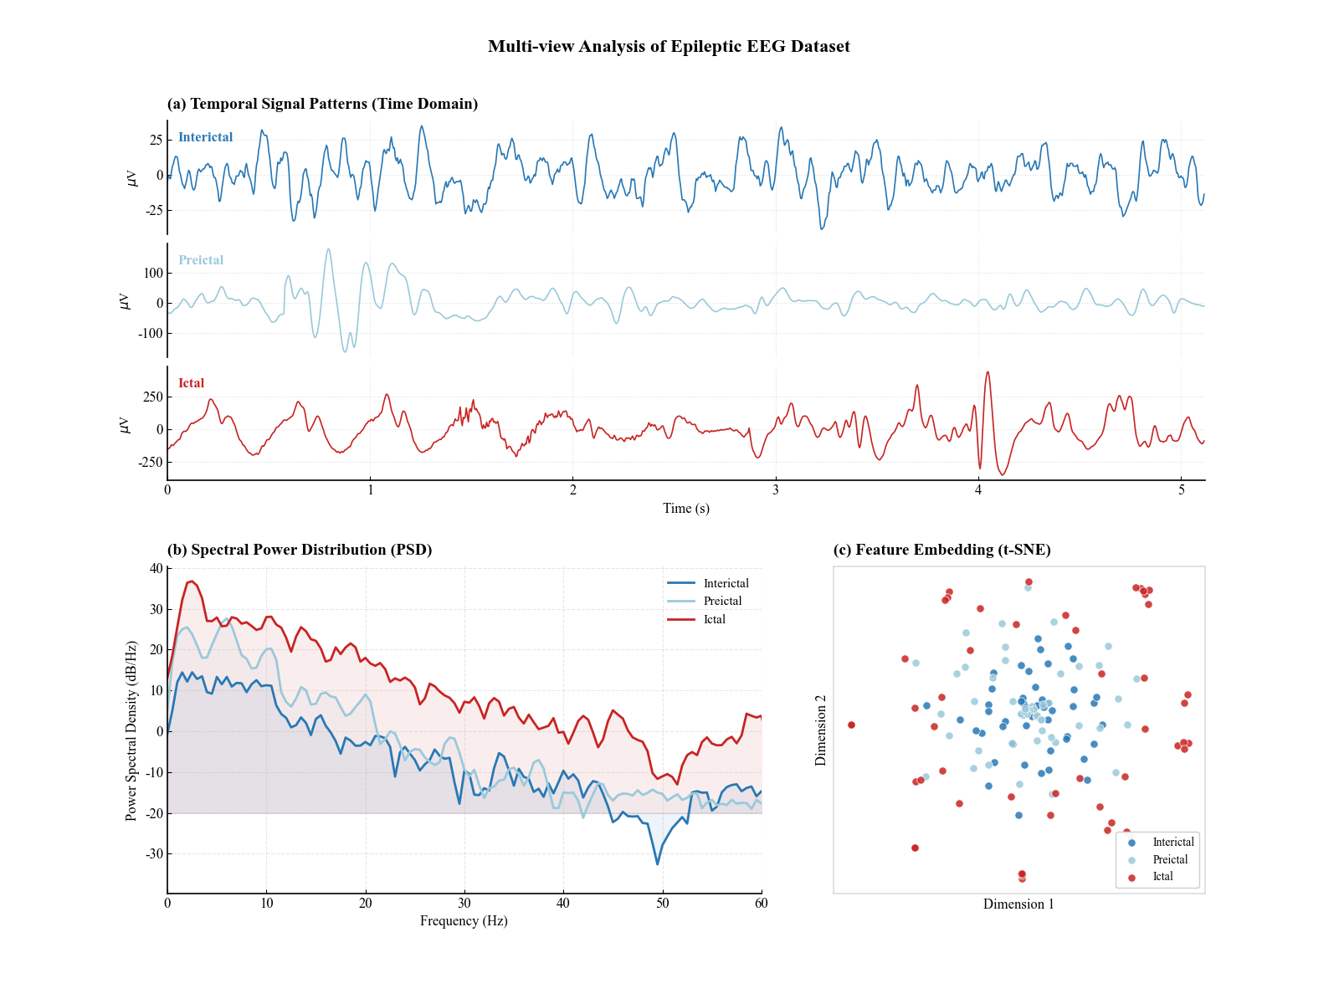


数据增强可视化代码
运行代码：
- import os
- import numpy as np
- import scipy.io as sio
- import pandas as pd
- import matplotlib.pyplot as plt
- import seaborn as sns
- from sklearn.preprocessing import LabelEncoder

- # ==========================================
- # 1. 全局绘图风格配置
- # ==========================================
- def set_pub_style():
- # 使用 Seaborn 的 paper 上下文，字体略大，适合阅读
- sns.set_context("paper", font_scale=1.5)
- sns.set_style("ticks") # 仅显示刻度，背景留白

- # 字体设置
- plt.rcParams['font.family'] = 'sans-serif'
- plt.rcParams['font.sans-serif'] = ['Arial', 'SimHei'] # 优先英文Arial，兼顾中文
- plt.rcParams['axes.unicode_minus'] = False

- # 线条与配色
- plt.rcParams['lines.linewidth'] = 1.5
- plt.rcParams['axes.grid'] = True
- plt.rcParams['grid.alpha'] = 0.3
- plt.rcParams['grid.linestyle'] = '--'

- # 自定义配色方案
- # 蓝色代表原始，红色代表增强（警示/变化）
- return ["#4C72B0", "#C44E52", "#55A868"]

- colors = set_pub_style()

- # ==========================================
- # 2. 全局参数与增强算法
- # ==========================================
- FS = 200 # 采样率 200Hz
- DURATION = 5.12 # 持续时间
- N_SAMPLES = 1024 # 采样点数
- CLASSES = ['interictal', 'preictal', 'ictal']
- DATASET_PATH = r".\EEGEpilepsyDatasets" # 修正为原始字符串防止转义

- def data_augmentation(signal, noise_level=0.05, scale_range=(0.9, 1.1)):
- """
- 数据增强：噪声注入 + 幅度缩放
- :param signal: 原始 1D 信号
- :param noise_level: 高斯噪声的标准差系数 (相对于信号标准差)
- :param scale_range: 随机缩放因子的范围
- :return: 增强后的信号
- """
- # 1. 幅度缩放 (Scaling): 模拟不同受试者的信号强度差异
- scale_factor = np.random.uniform(scale_range[0], scale_range[1])
- scaled_signal = signal * scale_factor

- # 2. 噪声注入 (Jittering): 模拟采集设备的背景噪声
- # 计算信号自身的标准差，以此为基准添加噪声
- sigma = np.std(scaled_signal)
- noise = np.random.normal(0, sigma * noise_level, size=scaled_signal.shape)

- augmented_signal = scaled_signal + noise
- return augmented_signal

- def load_raw_data_with_augmentation(root_path):
- """
- 加载真实数据并进行增强
- 返回: (原始信号列表, 增强信号列表, 标签列表)
- """
- raw_signals = []
- aug_signals = []
- labels = []

- print(f"--- 开始加载数据: {root_path} ---")

- for class_name in CLASSES:
- folder_path = os.path.join(root_path, class_name)
- if not os.path.exists(folder_path):
- print(f"警告: 目录 {folder_path} 不存在，跳过。")
- continue

- files = [f for f in os.listdir(folder_path) if f.endswith('.mat')]
- print(f"正在处理类别 '{class_name}': 发现 {len(files)} 个文件")

- for file in files:
- mat_path = os.path.join(folder_path, file)
- try:
- mat_data = sio.loadmat(mat_path)
- # 自动查找不以 '__' 开头的变量名作为数据键
- key = [k for k in mat_data.keys() if not k.startswith('__')][0]
- signal = mat_data[key].flatten()

- # 确保数据长度统一为 1024
- if len(signal) > N_SAMPLES:
- signal = signal[:N_SAMPLES]
- elif len(signal) < N_SAMPLES:
- # 如果不足，进行零填充（虽然数据集描述说是1024，但做个防御性编程）
- signal = np.pad(signal, (0, N_SAMPLES - len(signal)), 'constant')

- # 1. 保存原始数据
- raw_signals.append(signal)
- labels.append(class_name)

- # 2. 生成并保存增强数据 (这里演示1倍扩充，即数据量翻倍)
- aug_sig = data_augmentation(signal)
- aug_signals.append(aug_sig)
- # 如果需要将增强数据加入训练集，这里也应该 append label
- # labels.append(class_name)

- except Exception as e:
- print(f"文件 {file} 读取错误: {e}")

- return np.array(raw_signals), np.array(aug_signals), np.array(labels)

- # ==========================================
- # 3. 执行数据加载
- # ==========================================

- # 加载数据
- X_raw, X_aug, y = load_raw_data_with_augmentation(DATASET_PATH)

- # 标签编码
- label_encoder = LabelEncoder()
- y_encoded = label_encoder.fit_transform(y)

- print(f"\n数据加载完成 Summary:")
- print(f"原始样本数: {X_raw.shape}")
- print(f"增强样本数: {X_aug.shape}")
- print(f"类别映射: {dict(zip(label_encoder.classes_, label_encoder.transform(label_encoder.classes_)))}")

- # ==========================================
- # 4. 可视化设计 (CS顶刊风格对比图)
- # ==========================================

- def visualize_augmentation_impact(raw, aug, label_name, sample_idx=0):
- """
- 绘制原始信号与增强信号的对比图
- """
- time_axis = np.linspace(0, DURATION, N_SAMPLES)

- # 创建画布：宽, 高 (英寸)
- fig = plt.figure(figsize=(12, 8))
- # 使用 GridSpec 进行复杂的子图布局
- gs = fig.add_gridspec(2, 2, height_ratios=[1.5, 1])

- # --- 子图 1: 时域波形对比 (占据上方整行) ---
- ax1 = fig.add_subplot(gs[0, :])

- # 绘制原始信号 (深色，实线)
- ax1.plot(time_axis, raw, color=colors[0], label='Original Signal',
- alpha=0.9, linewidth=1.5)
- # 绘制增强信号 (红色，半透明，虚线或细线，便于观察重叠)
- ax1.plot(time_axis, aug, color=colors[1], label='Augmented (Jitter+Scale)',
- alpha=0.6, linewidth=1.2, linestyle='--')

- ax1.set_title(f"Data Augmentation Effect - Class: {label_name} (Sample #{sample_idx})",
- fontweight='bold', pad=15)
- ax1.set_ylabel("Amplitude ($\mu$V)")
- ax1.set_xlabel("Time (s)")
- ax1.legend(loc='upper right', frameon=True, framealpha=0.9)
- ax1.set_xlim(0, 2) # 仅展示前2秒以看清细节，全长5.12s太密

- # 美化边框 (去掉上方和右侧边框)
- sns.despine(ax=ax1)

- # --- 子图 2: 局部放大细节 (左下) ---
- ax2 = fig.add_subplot(gs[1, 0])
- zoom_start, zoom_end = 200, 300 # 放大第200到300个采样点
- t_zoom = time_axis[zoom_start:zoom_end]

- ax2.plot(t_zoom, raw[zoom_start:zoom_end], color=colors[0], marker='o', markersize=4, label='Raw')
- ax2.plot(t_zoom, aug[zoom_start:zoom_end], color=colors[1], marker='x', markersize=4, label='Augmented')

- ax2.set_title("Local Detail (Zoom In)", fontsize=12)
- ax2.set_xticks([]) # 去掉X轴刻度，简化视觉
- sns.despine(ax=ax2)

- # --- 子图 3: 幅值分布密度对比 (右下) ---
- # 作用阐述：证明增强后的数据没有改变数据的基本统计分布，只是增加了多样性
- ax3 = fig.add_subplot(gs[1, 1])

- sns.kdeplot(raw, color=colors[0], fill=True, ax=ax3, label='Original Dist', alpha=0.3)
- sns.kdeplot(aug, color=colors[1], fill=True, ax=ax3, label='Augmented Dist', alpha=0.3)

- ax3.set_title("Amplitude Distribution (KDE)", fontsize=12)
- ax3.set_xlabel("Signal Amplitude")
- ax3.set_ylabel("Density")
- ax3.legend(fontsize=10)
- sns.despine(ax=ax3)

- plt.tight_layout()
- plt.show()

- # 选择一个 'ictal' (发作期) 的样本进行展示
- # 找到类别为 'ictal' 的索引
- ictal_indices = np.where(y == 'ictal')[0]
- if len(ictal_indices) > 0:
- sample_idx = ictal_indices[0] # 取第一个
- print(f"\n正在生成可视化对比图，样本索引: {sample_idx} (Type: Ictal)...")
- visualize_augmentation_impact(X_raw[sample_idx], X_aug[sample_idx], 'Ictal', sample_idx)
- else:
- print("未找到 Ictal 类别数据用于绘图，请检查数据路径。")

绘图结果：
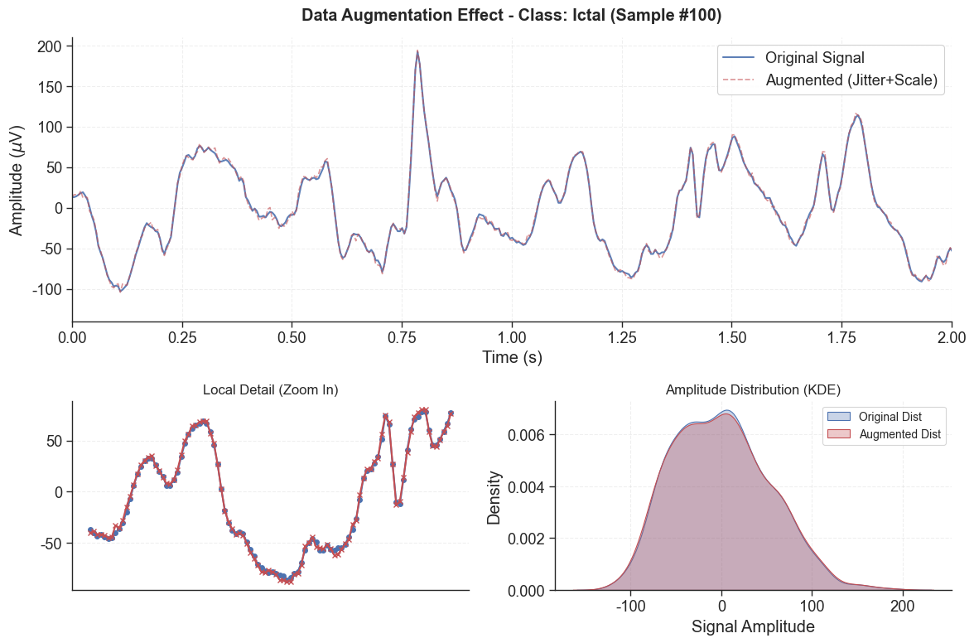

训练姐+测试集 模型评估可视化
运行代码：
- import os
- import pickle
- import json
- import numpy as np
- import pandas as pd
- import seaborn as sns
- import matplotlib.pyplot as plt
- from matplotlib import cm
- # [修正] 删除已被废弃的 scipy.interp，直接使用 numpy.interp
- from sklearn.metrics import roc_curve, auc
- from sklearn.preprocessing import label_binarize
- from sklearn.feature_selection import SelectKBest, f_classif
- import warnings

- # ==========================================
- # 全局配置
- # ==========================================
- warnings.filterwarnings('ignore')

- # 路径配置
- RESULTS_ROOT = r".\A10_eeg_epilepsy_lasso0.5"
- DATA_FOR_PLOTS = os.path.join(RESULTS_ROOT, "data_for_plots", "comprehensive_tuning_results.pkl")
- FEATURES_PATH = os.path.join(RESULTS_ROOT, "features", "train_features.csv")
- REPORTS_DIR = os.path.join(RESULTS_ROOT, "reports")
- PLOTS_OUTPUT_DIR = os.path.join(RESULTS_ROOT, "publication_plots0")
- os.makedirs(PLOTS_OUTPUT_DIR, exist_ok=True)

- # 绘图风格设置
- plt.rcParams['font.family'] = 'serif'
- plt.rcParams['font.serif'] = ['Times New Roman']
- plt.rcParams['axes.labelsize'] = 14
- plt.rcParams['axes.titlesize'] = 16
- plt.rcParams['xtick.labelsize'] = 12
- plt.rcParams['ytick.labelsize'] = 12
- plt.rcParams['legend.fontsize'] = 12
- plt.rcParams['figure.titlesize'] = 18
- plt.rcParams['axes.grid'] = True
- plt.rcParams['grid.alpha'] = 0.3
- plt.rcParams['grid.linestyle'] = '--'

- # 定义类别
- CLASSES = ['interictal', 'preictal', 'ictal']
- N_CLASSES = len(CLASSES)

- # 加载数据
- print("Loading data...")
- if not os.path.exists(DATA_FOR_PLOTS):
- raise FileNotFoundError(f"找不到数据文件: {DATA_FOR_PLOTS}，请确保第一步训练脚本已运行完毕。")

- with open(DATA_FOR_PLOTS, 'rb') as f:
- comprehensive_results = pickle.load(f)

- # 提取所有模型名称用于排序
- MODEL_KEYS = list(comprehensive_results.keys())
- BASE_MODELS = sorted(list(set([k.split('_')[0] for k in MODEL_KEYS])))

- # ==========================================
- # 多分类 ROC 曲线 (带置信区间)
- # ==========================================
- def plot_multiclass_roc():
- print("Generating 3. Multi-class ROC Curves...")

- n_plots = len(MODEL_KEYS)

- fig, axes = plt.subplots(n_rows, n_cols, figsize=(24, 6 * n_rows))
- axes = axes.flatten()

- # 定义插值点
- mean_fpr = np.linspace(0, 1, 100)

- for idx, model_key in enumerate(MODEL_KEYS):
- ax = axes[idx]
- res = comprehensive_results[model_key]
- cv_preds = res['cv_predictions_for_roc'] # list of (y_true, y_proba)

- tprs_dict = {c: [] for c in range(N_CLASSES)}
- aucs_dict = {c: [] for c in range(N_CLASSES)}

- # 遍历每一折
- for y_true, y_proba in cv_preds:
- # 二值化标签
- y_true_bin = label_binarize(y_true, classes=[0, 1, 2])

- # 如果某折验证集缺少某一类（极端情况），做容错处理
- if y_true_bin.shape[1] != N_CLASSES:
- # 简单填充0列，虽然通常StratifiedKFold不会发生这种情况
- temp = np.zeros((y_true_bin.shape[0], N_CLASSES))
- temp[:, :y_true_bin.shape[1]] = y_true_bin
- y_true_bin = temp

- for i in range(N_CLASSES):
- # 某些算法可能对某些类预测概率全为0或nan
- if np.sum(y_true_bin[:, i]) == 0:
- continue

- fpr, tpr, _ = roc_curve(y_true_bin[:, i], y_proba[:, i])
- # [核心修正] 使用 numpy.interp
- tprs_dict[i].append(np.interp(mean_fpr, fpr, tpr))
- tprs_dict[i][-1][0] = 0.0
- aucs_dict[i].append(auc(fpr, tpr))

- colors = [ '#348ABD', '#988ED5', '#E24A33'] # Blue, Purple, Red
- for i in range(N_CLASSES):
- if len(tprs_dict[i]) == 0: continue

- mean_tpr = np.mean(tprs_dict[i], axis=0)
- mean_tpr[-1] = 1.0
- mean_auc = auc(mean_fpr, mean_tpr)
- std_auc = np.std(aucs_dict[i])

- label = f'{CLASSES[i]} (AUC={mean_auc:.2f}$\pm${std_auc:.2f})'
- ax.plot(mean_fpr, mean_tpr, color=colors[i], label=label, lw=2)

- std_tpr = np.std(tprs_dict[i], axis=0)
- tprs_upper = np.minimum(mean_tpr + std_tpr, 1)
- tprs_lower = np.maximum(mean_tpr - std_tpr, 0)
- ax.fill_between(mean_fpr, tprs_lower, tprs_upper, color=colors[i], alpha=0.15)

- ax.plot([0, 1], [0, 1], 'k--', lw=1, alpha=0.5)
- ax.set_xlim([0.0, 1.0])
- ax.set_ylim([0.0, 1.05])
- ax.set_xlabel('False Positive Rate')
- ax.set_ylabel('True Positive Rate')
- ax.set_title(f'{model_key.replace("_", " + ")}', fontsize=12, fontweight='bold')
- ax.legend(loc="lower right", fontsize=10)

- for i in range(idx + 1, len(axes)):
- axes[i].axis('off')

- plt.tight_layout()
- plt.savefig(os.path.join(PLOTS_OUTPUT_DIR, "3_multiclass_roc_cv.pdf"), dpi=300)
- plt.close()

- # ==========================================
- # 混淆矩阵 (百分比)
- # ==========================================
- def plot_confusion_matrices():
- print("Generating 7. Confusion Matrices...")

- n_plots = len(MODEL_KEYS)
- n_cols = 4
- n_rows = (n_plots + n_cols - 1) // n_cols

- fig, axes = plt.subplots(n_rows, n_cols, figsize=(20, 5 * n_rows))
- axes = axes.flatten()

- for idx, model_key in enumerate(MODEL_KEYS):
- ax = axes[idx]

- cm_path = os.path.join(REPORTS_DIR, f"confusion_matrix_{model_key}.csv")
- if not os.path.exists(cm_path):
- ax.text(0.5, 0.5, "Missing CM File", ha='center')
- continue

- cm_df = pd.read_csv(cm_path, index_col=0)
- cm_values = cm_df.values

- cm_sum = np.sum(cm_values, axis=1, keepdims=True)
- cm_perc = cm_values / (cm_sum + 1e-10)

- sns.heatmap(cm_perc, annot=True, fmt='.1%', cmap='Blues',
- xticklabels=CLASSES, yticklabels=CLASSES,
- cbar=False, ax=ax, annot_kws={"size": 12})

- ax.set_title(model_key.replace('_', ' + '), fontsize=13, fontweight='bold')
- ax.set_ylabel('True Label')
- ax.set_xlabel('Predicted Label')

- for i in range(idx + 1, len(axes)):
- axes[i].axis('off')

- plt.tight_layout()
- plt.savefig(os.path.join(PLOTS_OUTPUT_DIR, "confusion_matrices.pdf"), dpi=300)
- plt.close()

- # ==========================================
- # 主执行入口
- # ==========================================
- if __name__ == "__main__":
- print(f"Starting plot generation. Outputs will be in: {PLOTS_OUTPUT_DIR}")

- try:
- plot_multiclass_roc()
- plot_confusion_matrices()

- print("\nAll plots generated successfully!")
- except Exception as e:
- print(f"An error occurred: {e}")
- import traceback

- traceback.print_exc()

绘图结果：
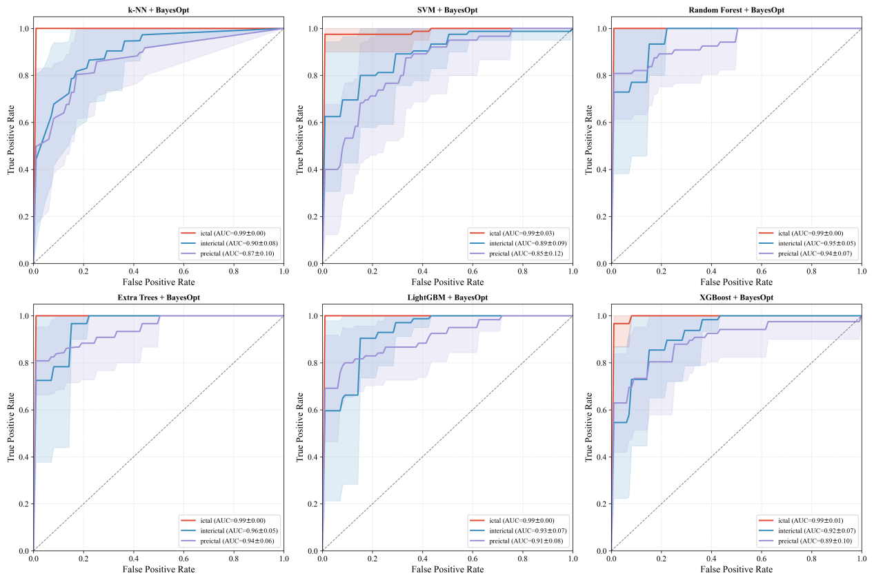
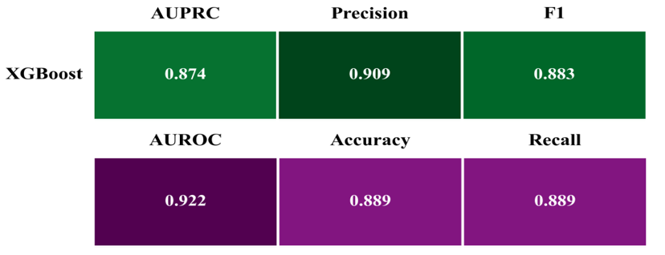
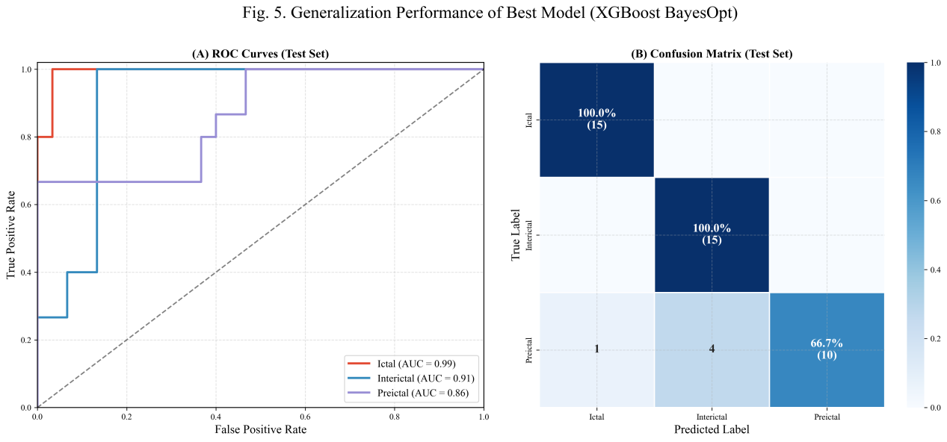

Shap分析绘图代码
运行代码：
- import os
- import sys
- import pickle
- import numpy as np
- import pandas as pd
- import matplotlib.pyplot as plt
- import seaborn as sns
- import shap
- from matplotlib import rcParams
- from matplotlib.ticker import MaxNLocator
- from pathlib import Path
- from sklearn.metrics import accuracy_score
- from matplotlib.colors import LinearSegmentedColormap

- plt.style.use('default')
- rcParams.update({
- 'font.family': 'Times New Roman',
- 'font.size': 12,
- 'axes.labelsize': 14,
- 'axes.titlesize': 16,
- 'xtick.labelsize': 12,
- 'ytick.labelsize': 12,
- 'legend.fontsize': 11,
- 'lines.linewidth': 2.5,
- 'axes.linewidth': 2,
- 'grid.linewidth': 0.7,
- 'savefig.dpi': 600,
- 'savefig.format': 'pdf',
- 'axes.edgecolor': 'black',
- 'axes.labelcolor': 'black',
- 'xtick.color': 'black',
- 'ytick.color': 'black',
- 'axes.spines.top': True,
- 'axes.spines.right': True,
- })

- # 配色方案
- COLOR_PALETTE = {
- 'main': '#3b5b92',
- 'ci': '#8395b1',
- 'positive': '#36a168', # 绿色
- 'negative': '#e05263', # 红色
- 'data': '#e0e0e0',
- 'zero_line': '#666666',
- 'background': '#f9f9f9',
- 'heatmap_high': '#b2182b',
- 'heatmap_low': '#2166ac'
- }

- # 自定义用于 Summary Plot 的红蓝渐变色图 (符合科研直觉: 红高蓝低)
- cmap_scientific = LinearSegmentedColormap.from_list(
- 'sci_cmap', ['#4575b4', '#d73027']
- )

- # ======================
- # 2. 绘图功能函数
- # ======================

- def plot_scientific_summary(shap_values, X_df, class_name, ax):
- """
- 绘制科研风格的 SHAP Summary Plot (Beeswarm)
- """
- plt.sca(ax) # 设置当前轴

- # 绘制 Summary Plot
- # show=False 允许我们在当前 ax 上继续修饰
- shap.summary_plot(shap_values, X_df,
- show=False,
- plot_type="dot",
- max_display=10,
- cmap=cmap_scientific,
- alpha=0.8,
- plot_size=None) # plot_size=None 适配当前 ax

- # 获取当前 colorbar 并修饰
- # shap 的 summary_plot 会自动添加 colorbar，但我们可能需要调整它的字体
- fig = plt.gcf()
- if len(fig.axes) > 1:
- # 通常最后一个轴是 colorbar
- cbar_ax = fig.axes[-1]
- cbar_ax.set_ylabel('Feature Value', fontsize=12, fontname='Times New Roman')
- cbar_ax.tick_params(labelsize=10)

- # 修饰主坐标轴
- ax.set_xlabel('SHAP Value (Impact on Model Output)', fontsize=14, fontweight='bold')
- ax.set_title(f'Global Interpretability: {class_name}', fontsize=16, fontweight='bold', pad=15)

- # 加粗边框
- for spine in ax.spines.values():
- spine.set_linewidth(2)

- # 调整 Y 轴标签字体
- ax.tick_params(axis='y', labelsize=12)

- def plot_scientific_waterfall(base_value, shap_values_single, feature_names, class_name, ax, instance_idx):
- """
- 绘制科研风格的单样本 Waterfall/Bar 图 (Case Study)
- """
- # 1. 排序特征贡献
- # 找出绝对值最大的前 10 个特征
- top_k = 10
- indices = np.argsort(np.abs(shap_values_single))[-top_k:]

- values = shap_values_single[indices]
- names = feature_names[indices]

- # 2. 颜色映射
- colors = [COLOR_PALETTE['positive'] if v > 0 else COLOR_PALETTE['negative'] for v in values]

- # 3. 绘图
- y_pos = np.arange(len(values))
- ax.barh(y_pos, values, color=colors, edgecolor='black', height=0.6, zorder=3)

- # 4. 装饰
- ax.set_yticks(y_pos)
- ax.set_yticklabels(names)
- ax.axvline(0, color='black', linewidth=1.5, zorder=2)
- ax.grid(axis='x', linestyle='--', alpha=0.5, zorder=0)

- # 添加数值标签
- for i, v in enumerate(values):
- offset = max(values) * 0.02 if v > 0 else -max(abs(values)) * 0.02
- ha = 'left' if v > 0 else 'right'
- ax.text(v + offset, i, f'{v:.3f}', va='center', ha=ha, fontsize=10, fontweight='bold')

- # 标题和标签
- ax.set_xlabel('Contribution to Log-Odds', fontsize=12, fontweight='bold')
- ax.set_title(f'Case Study (Sample #{instance_idx}): {class_name}\nBase Value: {base_value:.3f}',
- fontsize=14, fontweight='bold')

- # 去除顶部和右侧边框
- ax.spines['right'].set_visible(False)
- ax.spines['top'].set_visible(False)

- def plot_feature_interaction_heatmap(shap_values, feature_names, class_name, ax):
- """
- 绘制 SHAP 值的相关性热力图，展示特征协同作用
- """
- # 选取 top 10 重要特征进行相关性分析
- mean_abs_shap = np.mean(np.abs(shap_values), axis=0)
- top_indices = np.argsort(mean_abs_shap)[::-1][:10]

- top_shap_vals = shap_values[:, top_indices]
- top_names = feature_names[top_indices]

- # 计算相关系数矩阵
- corr_matrix = np.corrcoef(top_shap_vals.T)

- # 绘图
- sns.heatmap(corr_matrix, ax=ax, annot=True, fmt=".2f",
- cmap="RdBu_r", center=0, square=True,
- xticklabels=top_names, yticklabels=top_names,
- cbar_kws={"shrink": 0.8},
- annot_kws={"size": 9})

- ax.set_title(f'Feature Interaction (SHAP Correlation): {class_name}', fontsize=16, fontweight='bold', pad=15)
- ax.tick_params(axis='x', rotation=45, labelsize=10)
- ax.tick_params(axis='y', rotation=0, labelsize=10)

- # ======================
- # 主程序逻辑
- # ======================
- def main():
- print("--- Starting Advanced SHAP Analysis ---")

- # 1. 路径设置 (与您原始代码一致)
- base_dir_str = r"./A10_eeg_epilepsy_lasso0.5_plus1"
- base_path = Path(base_dir_str)
- pkl_filename = "shap_visualization_data_all_models.pkl"
- file_path = base_path / pkl_filename

- output_dir = base_path / "SHAP_Advanced_Analysis"
- output_dir.mkdir(parents=True, exist_ok=True)

- if not file_path.exists():
- print(f"Error: Could not find '{pkl_filename}'")
- return

- # 2. 加载数据
- print(f"Loading data from: {file_path}")
- with open(file_path, 'rb') as f:
- data_packet = pickle.load(f)

- models_dict = data_packet['models_dict']
- X_train_bg = data_packet['X_train_bg']
- X_test = data_packet['X_test']
- y_test = data_packet['y_test']
- feature_names = np.array(data_packet['feature_names'])
- class_names = data_packet['class_names']

- X_all = np.vstack([X_train_bg, X_test])

- # 3. 选择最佳模型
- best_acc = -1
- best_model_key = None
- best_pipeline = None

- for key, pipeline in models_dict.items():
- try:
- y_pred = pipeline.predict(X_test)
- acc = accuracy_score(y_test, y_pred)
- if acc > best_acc:
- best_acc = acc
- best_model_key = key
- best_pipeline = pipeline
- except:
- continue

- print(f"Best Model: {best_model_key} (Acc: {best_acc:.4f})")

- # 4. 特征处理 & SHAP 计算
- scaler = best_pipeline.named_steps['scaler']
- selector = best_pipeline.named_steps['feature_selection']
- clf = best_pipeline.named_steps['clf']

- X_scaled = scaler.transform(X_all)
- X_final = selector.transform(X_scaled)
- support_mask = selector.get_support()
- selected_feature_names = feature_names[support_mask]

- X_final_df = pd.DataFrame(X_final, columns=selected_feature_names)

- print("Calculating SHAP values...")
- try:
- explainer = shap.TreeExplainer(clf)
- # check_additivity=False 防止因精度问题报错
- shap_values_raw = explainer.shap_values(X_final_df, check_additivity=False)
- # 获取 base_value (expected_value)
- if isinstance(explainer.expected_value, list):
- base_values = explainer.expected_value
- else:
- base_values = [explainer.expected_value] * len(class_names)
- except:
- # Fallback for KernelExplainer
- X_summary = shap.kmeans(X_final[:100], 10)
- explainer = shap.KernelExplainer(clf.predict_proba, X_summary)
- shap_values_raw = explainer.shap_values(X_final_df)
- base_values = [0.33] * 3 # 估算值

- # 整理 SHAP values 格式
- if isinstance(shap_values_raw, list):
- shap_values_list = shap_values_raw
- elif isinstance(shap_values_raw, np.ndarray) and len(shap_values_raw.shape) == 3:
- shap_values_list = [shap_values_raw[:, :, i] for i in range(shap_values_raw.shape[2])]
- else:
- shap_values_list = [shap_values_raw] # 二分类情况

- # 5. 定义类别顺序 (Interictal, Preictal, Ictal)
- target_order_indices = [1, 2, 0]
- target_order_names = ['Interictal', 'Preictal', 'Ictal']

- # ==========================================
- # 绘图 1: 全局 Summary Plot (3个类别合并长图)
- # ==========================================
- print("Generating Summary Plots...")
- fig_summary, axes_summary = plt.subplots(1, 3, figsize=(24, 8))
- plt.subplots_adjust(wspace=0.4)

- for i, (class_idx, class_name) in enumerate(zip(target_order_indices, target_order_names)):
- if class_idx < len(shap_values_list):
- plot_scientific_summary(shap_values_list[class_idx], X_final_df, class_name, axes_summary[i])

- fig_summary.savefig(output_dir / "SHAP_Global_Summary.pdf", bbox_inches='tight')
- fig_summary.savefig(output_dir / "SHAP_Global_Summary.png", bbox_inches='tight', dpi=300)
- plt.close(fig_summary)

- # ==========================================
- # 绘图 2: 特征交互热力图
- # ==========================================
- print("Generating Interaction Heatmaps...")
- fig_heat, axes_heat = plt.subplots(1, 3, figsize=(26, 8))
- plt.subplots_adjust(wspace=0.3)

- for i, (class_idx, class_name) in enumerate(zip(target_order_indices, target_order_names)):
- if class_idx < len(shap_values_list):
- plot_feature_interaction_heatmap(shap_values_list[class_idx], selected_feature_names,
- class_name, axes_heat[i])

- fig_heat.savefig(output_dir / "SHAP_Interaction_Heatmap.pdf", bbox_inches='tight')
- fig_heat.savefig(output_dir / "SHAP_Interaction_Heatmap.png", bbox_inches='tight', dpi=300)
- plt.close(fig_heat)

- print("All Advanced SHAP plots saved successfully.")

- if __name__ == "__main__":
- main()

绘图结果：
